2024

Local Township Area Information for Emergency Planning for Communities

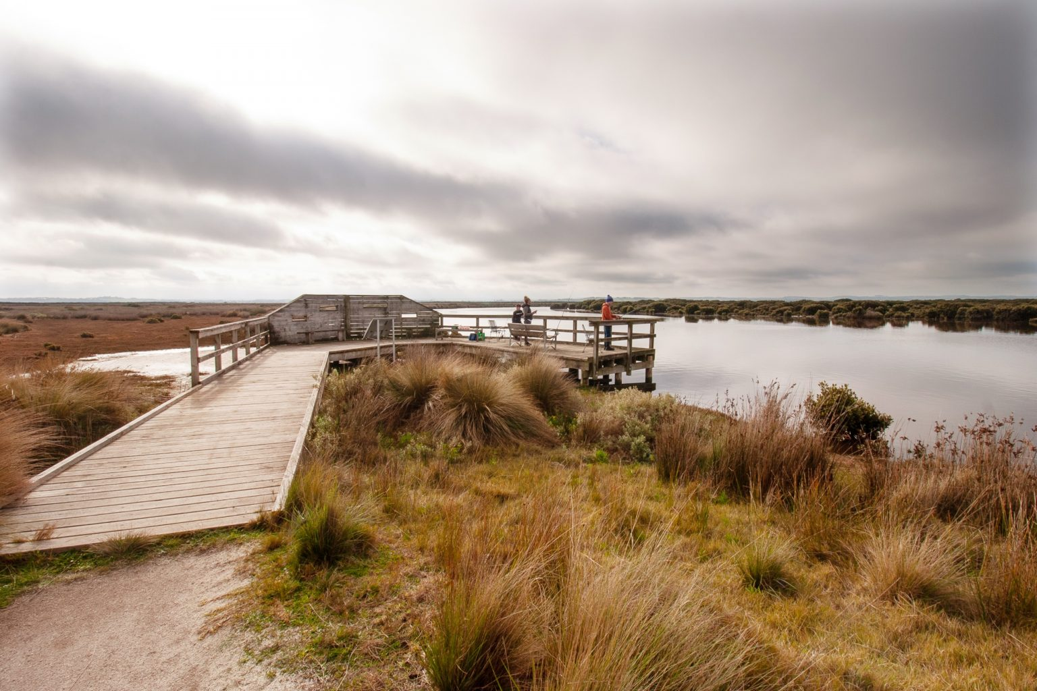

Venus Bay Emergency Planning Information

**Background**

This plan was developed as an outcome of the funding provided through the ERV Community Led Recovery Funding program which identified opportunities for emergency services agencies, essential infrastructure owners and Council to share information on planning completed in relation to emergency incidents.

The plan will be used to help integrated planning around emergency events by agencies and to support resilience building activities within the Venus Bay community. The plan will be recognised as a Community Emergency Management Plan in the Municipal Emergency Management Plan and will be reviewed as part of the MEMP 3 yearly review cycle.

Feedback on the document can be provided to [em@southgippsland.vic.gov.au](mailto:em@southgippsland.vic.gov.au)

|  |
| --- |
| **Community’s disaster risk profile (including any relevant disaster history) in Venus Bay:** |
| **Bushfire**  **Venus Bay has an Extreme bushfire risk level**   * **There is no community alerting siren** * **There is no Neighbourhood Safer Place – Place of Last Resort** * **There is no Community Fire Refuge**   **On Extreme or Catastrophic days you should not be in a bush fire risk area. Venus Bay is in West and South Gippsland Fire District – check the the Fire Danger Rating, daily at cfa.vic.gov.au or call 1800 226 226**  Victoria is one of the most fire-prone areas in the world. Understanding your level of risk is the first step in knowing what to do before and during a fire. Burning scrub, heath or other coastal vegetation can create hot, dangerous bushfires. If you live by, work by or travel to the coast you are at risk. Beaches, foreshores and shallow waters may not be safe or protect you from radiant heat. Often a fire will be burning between you and the beach.  What can you expect?   * Very hot and fast-moving fires. * Gusty ocean winds causing fire to behave erratically. * A lot of embers. * Fire reaching houses quickly. * Busy, congested coastal roads. * Radiant heat (the heat created by a fire)   What to do   * You need to prepare your property for fire before summer starts. * Decide when you will leave and where you will go on hot, dry, windy days when the risk of a fire starting is increased. * Stay informed on hot, dry, windy days by monitoring conditions outside and tuning into a local emergency broadcaster, checking [emergency.vic.gov.au](http://www.emergency.vic.gov.au/) regularly and by downloading the VicEmergency app. * Leaving early is the safest option to protect yourself and your family.   Source - [Am I at Risk? | CFA (Country Fire Authority)](https://www.cfa.vic.gov.au/plan-prepare/bushfire-basics/am-i-at-risk)  A bushfire burning under a North/Northwesterly windflow has the potential to impact the whole of Venus Bay township (all three estates) in a short time frame. The following South Westerly wind change will also directly impact the remaining developed areas of Venus Bay.  A major risk of ignition in the Venus Bay area is from an internal source which has the potential under under high and above fire danger rating conditions to develop quickly.  Due to the high fuel loads within and surrounding the township and proximity of dwellings to vegetation any fire ignition under the influence of the above wind pattern will develop quickly and be difficult to contain. There is a high likelihood the main access road may get blocked and people may need to shelter in place as plans to self evacuate may be compromised. Clear message around leaving early on extreme and catastrophic days should be provided.  **Fire History in Venus Bay and South Gippsland**  There is no major bushfire history for Venus Bay and the surrounding area however there have been 24 fire ignitions in the last 5 years. Under high and above fire danger rating conditions a fire is likely to spread and reach assets.   * **NYE 2021 -**A grassfire ignited on NYE 31 December 2021 on the farmland at the entrance of Venus Bay off Jupiter Boulevard and was contained. Approx 40 people sought refuge at the Venus Bay Surf Life Saving Club. There was no exit from Venus Bay for several hours due to Jupiter Boulevard and Inverloch Venus Bay Road being blocked due to smoke hazard. * **2012 -** Hallston Fire * **2009 -** Delburn Fire - The Delburn Complex Fire was deliberately lit and directly impacted 128 properties in the Darlimurla, Mirboo North and Boolarra areas   **Flood and Inundation**  The Tarwin River can flood due to prolonged rain over a number of days, causing the river to rise and burst its banks. The southern floodplain and areas downstream from the town towards Venus Bay are more likely to experience flooding from storm surges. It should be noted here that the DEECA Cape to Cape Resilience Plan and SGSC Coastal Strategy identify increasing risks of storm surge flooding of egress/access roads.  The Tarwin River has a history of flooding, including the Tarwin Lower and Venus Bay area. During flooding, the Tarwin River can change flow direction as it is influenced by the tides. When the tide is rising, and the river is flowing quickly due to high rainfalls upstream, the river can change direction slightly crossing the Inverloch-Venus Bay Road south of the Tarwin River Bridge near the fishing platforms. This area is incredibly dangerous for drivers and often closes during flooding.  When the tide is rising and rainfall in the Strzelecki is high, an important influence on the condition of the river levels is the wind direction, ie. A South Westerly wind will hold water in the inlet/river. The lowest point of land adjascent to the Tarwin River is at the intersection of School Rd and River Drive. The highest point is at the Tarwin Rec Reserve.The only local aquatic rescue agencies are SES (Primary) supported by the VBSLC, the SES is also responsible for a number of kayak rescues a year in Anderson inlet.  **Warnings for the Tarwin River**  The Tarwin River does not have tide guages therefore its difficult to predict flood levels (refer SES).  Warnings issued by BoM provide generic flood information, but not specifics such as river height predictions. Information about potential floods will also be available from SES www.ses.vic.gov.au **Tarwin Lower Local Flood Guide**. You can monitor rainfall and river levels on the BoM website at bom.gov.au  **Flood History**  **16 August 2022 -**The Tarwin River flooded over the Inverloch-Venus Bay Road and was heavily affected by flood waters for a period of 5 days. Residents from Venus Bay and Tarwin Lower had to travel on Walkerville Road via Meeniyan and Fish Creek to access main townships, which also impacted supply delivery into the Tarwin Lower and Venus Bay townships  **February 2016 -** 27mm of rain fell in a matter of minutes causing flooding across the shire.  **Severe Weather History**  **February 2024**  Damaging winds associated with thunderstorm activity brought trees down across the shire. Significant power outages occurred throughout the shire. Isolated properties off power for 3+ days.  **29 October 2021**  Severe flooding and winds heavily impacted the shire on 29 October 2021. Significant power outages occurred throughout the shire. Isolated properties off power for 3+ days.  **June 2021**  A cold front crossing south eastern Victoria bringing damaging winds and heavy localised rainfall was forecast for Wednesday 9 June 2021. Severe flooding and winds impacted the shire over the 9 & 10 of June 2021. Significant power outages occurred throughout the shire including Venus Bay with isolated properties off power for 3+ days.  Over 641 roads (essential public assets) were impacted by trees down, flooding and landslips impacted the Shire  **March 2018**  South Gippsland experienced significant damage as a result of a wind event that occurred on Sunday 18 March 2018  **2015 – 2016** – Drought – water restrictions in place  **2007 – 2010** – Drought – water restrictions in place |
| **Other relevant risk information** |
| * Access/egress in to and out of Venus Bay is extremely limited. * Police/Ambulance response times are restricted and there are limited medical services locally * Lack of public transport and connectivity. * Mobile phone communication around Venus Bay is generally good but during peak times may become unreliable. * Commercial and ABC radio reception in the area is good, local community radio from South Coast FM is received into Venus Bay (88.1MHz – Central: Korumburra, Leongatha, Wonthaggi, Inverloch). * There are telecommunications black spots in the Venus Bay area. * Utilities can be unreliable at peak periods. * Properties are on Tank water (no reticulated/mains supply) and all properties have Septic Tanks. In emergencies and power outages this can cause significant issues with accessing water and people should limit accessible water usage to essentials such as toilet flushing and hand washing. * Venus bay has a diverse population of residents from different socio-economic backgrounds. * New population of residents living 4 days a week in Venus Bay where they were previously weekenders. * Full time population is predominantly elderly retirees with few support services. There are also a number of young families moving in to the area. * **Drowning Risk** - Venus Bay’s beach stretches over 20 kilometres, and conditions across its length are ever changing throughout the day, with rips, sand bars, deep channels and strong currents acting along the entire beach length. Please help us in keeping everyone safe, only swim between the flags on beach 1. The Beachsafe app (beachsafe.org.au) will give you information on conditions, patrolled beaches and provide translations in many languages . [**bom.gov.au**](https://l.facebook.com/l.php?u=http%3A%2F%2Fbom.gov.au%2F%3Ffbclid%3DIwZXh0bgNhZW0CMTAAAR0hZpTS1DVKycuP1FHXqpixSQmJCvEVzoqs45svlv2Tn6RSWRJ1vdc5vlk_aem_uuStGUTBUQL60kFMoeLUQA&h=AT07JdyHyos2ZrO2hUU2PUge69dwJnpkZyXYlM1osTyctaOhFiByDGhekxBwWj-S24Lly24leA8Uw7txBazT3XQabU5JiO_BKhrr0aFYaj7E8aR9tcYqzeBvf7YDv6hxfw&__tn__=-UK-R&c%5b0%5d=AT25V1nKJGEyY9jiDQRb4cBzS2aaEK7LkmYtx6XbdRzuJyaWJWRG5SZcBaztTkzSP36cEc4ebMfitrKl9vEhgEtYYWfST4zbg-KM3G6GRaPm0W7BKEGUdQ3_0-cTyR5haotucO27d2Jp-AzeuTAQiUP69AAoHX9_wuRLQAapEOaqccovVyJ6cK5X0xGVAMJ5hQ) has the latest weather warnings including high tides to check the surf conditions. |
| **Roads** |
| Venus Bay has only one road connecting the 3 estates. The Venus Bay Inverloch Road is the only road in and out of Venus Bay.  **Primary Access / Egress Road**  The solitary access/egress road is the Inverloch Venus Bay Road that then becomes Jupiter Bvd. The section of this road through the township of Tarwin Lower is called River Drive.  **Secondary Access Roads**   * Canterbury Road * Lees Road * Centre Road * Fishermans Road (jetty access restricted by tide levels)   **The only road access into Venus Bay is via Tarwin Lower** |
| **Emergency Planning Information – Municipal Risk Information** |
| [South Gippsland Shire Council - Emergency Management Planning](https://www.southgippsland.vic.gov.au/homepage/52/emergency_management) |
| **Emergency Planning Resources** |
| There are many helpful tools to assist you in creating an emergency plan. Please see below links:   * [redcross.org.au/prepare](https://www.redcross.org.au/prepare) * [ses.vic.gov.au/get-ready/emergency-plans-and-kits](https://www.ses.vic.gov.au/get-ready/emergency-plans-and-kits) * [cfa.vic.gov.au/plan-prepare/your-bushfire-plan](https://www.cfa.vic.gov.au/plan-prepare/your-bushfire-plan)   An [Emergency Information sheet](https://www.southgippsland.vic.gov.au/downloads/file/4267/emergency_information_sheet) has been prepared by Council to help with the development of your Emergency Plan. It contains contact information and other useful prompts to help you develop your own plan. |
| **Staying updated - Victoria’s warning system** |
|  |

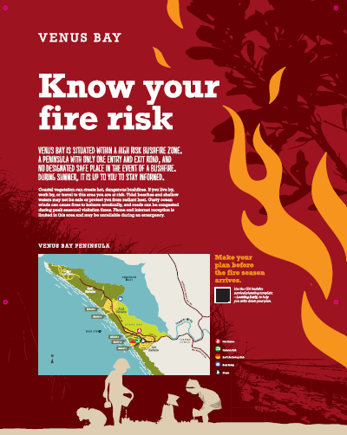

**Local Area Information to inform your emergency planning:**

|  |  |  |  |
| --- | --- | --- | --- |
| **Name of community:** | | **Local Government Area:** | **State or Territory:** |
| Venus Bay | | South Gippsland Shire Council | Victoria |
| Venus Bay is a small remote residential/coastal hamlet tucked behind some of the largest recorded sand dunes in Australia. It is positioned on a narrow peninsula located in the South Gippsland Shire Coastal Promontory Ward, 40 klms south of Leongatha and 174 klm south east of Melbourne.  The Venus Bay Township is in a residential/coastal setting with its boundaries defined by Cape Liptrap Coastal Park, Point Smythe Coastal Reserve, Anderson Inlet & Inverloch Venus Bay Road. A large part of the area is located on coastal dune which is heavily timbered with coastal scrub and open farmland to the East.  The township can be split into three distinct areas: Venus Bay Estates No. 1, 2 and 3, the town is predominately flat and the separation distance between vegetation and dwellings typically a lot less than 20m.  Access and egress is limited due to one road (Inverloch Venus Bay Rd) in and out of the township and between the first and second estates (Lees Rd).  Due to Venus Bay having a large proportion of short stay accommodation and unoccupied houses properties may not be well prepared; residents/owners/occupiers may be unaware of the extreme risk and community messaging regarding fire danger ratings and the ‘leave early’ directive. A large percentage of people will be unfamiliar with the area, the lack of services and utilities and dependence on power for water and communications whilst staying in Venus Bay.    [Locality snapshots – Venus Bay](https://profile.id.com.au/south-gippsland/locality-snapshots?WebID=22626200) | | | |
| **How many people live here?** | | **Where people can stay here?** | **Identify any peak periods for tourists and/or visitors?** |
| Official population data is difficult to ascertain due to changes in the part time and full-time population post covid not being reflected in the 2021 Census (900 full time). Venus Bay’s current full-time population is estimated to be between 1200 and 1500. This expands to between 5000 and 8000 over peak times, this includes day visitors. | No. of dwellings:  1828 with official data stating 515 permanently occupied and 72% unoccupied. Once again, this data gap is an ongoing challenge. | There is a high proportion of short stay accommodation available, as well as the Venus Bay Caravan Park. Some people camp on undeveloped blocks. | Peak Summer period (Nov – Feb)  Long weekends  Easter  School holidays |
| **Tourism** | | | |
| Venus Bay is a popular tourist destination in the summer with many holiday homes and day trippers using the numerous beach car parks and access tracks managed by Parks Victoria. As well as being known for its wild beaches the area is also visited for its various popular fishing, birdwatching and walking attractions. It is a holiday retreat for people from Melbourne and is close to other popular South Gippsland tourist spots such as Wilsons Promontory and Phillip Island. Venus Bay is a popular pipi fishery. If pippies are in abundance, it can add thousands of fishers on a peak summer day.    Many visitors are unfamiliar with the area and not aware of the risks associated with the dynamic and minimally serviced coastal environment. Many tourism hosts do not offer information regarding these risks.  On a peak summer day visitation will exceed available infrastructure (ie. Carparking) – and will add to traffic issues if an incident occurs. | | | |
| **Employment** | | | |
| Industries of employment include:   * Trades * Tourism * Hospitality/retail (ie. Pub/supermarket) | | | |
| **Transport** | | | |
| **Public transport Services**   * South Gippsland Regional Taxis * School buses operate within the Venus Bay area * The Venus Bay Community Centre operates a limited run beach courtesy bus for tourists and residents during the peak holiday period. This is to encourage tourists to swim between the flags at Venus Bay’s only patrolled beach. * Venus Bay Community Centre is undertaking a Community Transport pilot project (starting 2024) and has a 10 seat electric mini-bus that will be used to address transport needs | | | |
| **What services exist in this community to support local residents and visitors:**  *eg. medical centre, local hospital, police station, primary school, community house etc.* | | | |

|  |
| --- |
| **Supermarket & food**   * Small general store on Jupiter Ave - 1st estate * Various takeaway outlets * Tarwin IGA is main supermarket for VB   **Pharmacy**   * Venus Bay Pharmacy   **Bank**   * Nil – closest is Inverloch, Leongatha & Foster * Tarwin Lower post office   **Medical**   * VERY LIMITED services at the Tarwin Lower & District Community Health Centre (Nurse Practitioner and various allied health professionals by appointment [Tarwin Lower & District Community Health Centre (tarwinhealth.com.au)](https://www.tarwinhealth.com.au/) * Hospital -closest is Wonthaggi, Leongatha or Foster. Leongatha has no emergency dept. * Ambulance – closest Amulance Stations are Wonthaggi, Leongatha or Foster. Community are assisted in first response by the CERT (Community Emergency Response Team) – activated through 000. * Automatic External Defibrillator (AED) – DEFIB - 133 Jupiter Boulevard & other locations including Venus Bay Community Centre, Mens Shed, Angling Club and Venus Bay Surf Lifesaving Club.   **Aged Care**   * Nil – closest is Inverloch, Wonthaggi, Leongatha and Foster   **Fuel Supplies**   * Tarwin Lower Service Station   **Schools / Education**   * Tarwin Lower Primary School * Koonwarra Village School * Inverloch Primary School * Secondary Education – Newhaven, Foster and Leongatha   **Emergency Services**   * Venus Bay CFA (satellite station) * Tarwin Lower CFA * CERT – (Community Emergency Response Team) * Venus Bay Surf Life Saving Club   **Library** (Myli)   * Myli services run through the Venus Bay Community Centre from time to time.   **Churches**   * Tarwin Lower Union Church   **Accommodation**   * There are a number of short stay accommodation options, and the Venus Bay Caravan Park   **Other Services and facilities**   * Venus Bay Community Centre * Supported Playgroup - Tarwin Lower |

|  |
| --- |
| **Describe the economic / social / educational / sporting / community networks that connect this community:**  ***This is a representative list – check local websites/social media for more information*** |

|  |  |
| --- | --- |
| |  | | --- | | * Venus Bay Community Centre * Venus Bay Angling Club * Venus Bay – Tarwin Lower & District Men’s Shed * Tarwin Landcare * Wombat Walkers * Tarwin Lower – Venus Bay Tourism and Local Commerce Association (TALC) * Venus Bay Surf Life Saving Club * Tarwin Lower Recreation Reserve Committee Inc * Tarwin Football Netball Club * Tarwin Lower and District Bowling Club * Tarwin Lower Mechanics Institute Hall * Tarwin Lower Pony Club | |

|  |
| --- |
| **What communication channels and mediums are commonly used by the community?** |
| *e.g. local publications, community or local radio, newsletters, community Facebook page?*   * Venus Bay Community Centre facebook page * Venus Bay Matter of Fact Newsletter * Tarwin Lower/ Venus Bay Community Voice (large part time population) * Sentinel Times |

.

**Acknowledgement**

South Gippsland Shire Council was generously funded by the State of Victoria through Emergency Recovery Victoria's Community-led Recovery Support grant program in response to the June 2021 Storm Event which impacted Victorian communities in South Gippsland.

The funds were used to support the Venus Bay district to improve community disaster resilience planning and assisted with the development of this plan.

 